**Search Contacts in Odoo Contacts Module**

**(19L-1229-BCS-8A-1st User Story and Related Work)**

**User Story:** As a sales representative, I want to be able to search for contacts by name, email, or phone number, so that I can quickly find the contact information I need to make a sale.

**Equivalence Class Partitions:**

1. **Valid name search:** Searching for a contact by their first or last name, which is a valid input.
2. **Invalid name search:** Searching for a contact using an invalid name, such as special characters or numbers.
3. **Valid email search:** Searching for a contact by their email address, which is a valid input.
4. **Invalid email search:** Searching for a contact using an invalid email address, such as a malformed email address or an email address that does not exist.
5. **Valid phone number search:** Searching for a contact by their phone number, which is a valid input.
6. **Invalid phone number search:** Searching for a contact using an invalid phone number, such as a number with too many digits or special characters.
7. **Search by multiple fields:** Searching contact using a combination of name, email, and phone number.
8. **No matching contacts:** Searching for a contact that does not exist in the system.
9. **Multiple matching contacts:** Searching for a contact with a common name or email address that returns multiple matches.
10. **Case sensitivity:** Testing if the search is case sensitive or insensitive.

**Boundary Value Analysis:**

1. **Valid name search:**
   1. Minimum valid input: a single character name (e.g. "A")
   2. Maximum valid input: a name with the maximum allowed length (which may vary depending on the implementation, but let's say it's 50 characters)
   3. Just below minimum: an empty string
   4. Just above maximum: a name with 51 characters
2. **Valid email search:** Assuming that the email field can contain up to 254 characters
   1. Lower boundary: An email address with the minimum number of characters allowed (1). Example: a@example.com
   2. Nominal value: An email address with a length of 50 characters. Example: [john.doe1234567890abcdefghijklmnopqrstuvwxyz@example.com](mailto:john.doe1234567890abcdefghijklmnopqrstuvwxyz@example.com)
   3. Upper boundary: An email address with the maximum number of characters allowed (254).
3. **Valid phone number search:**
4. **Valid input:** (000)-000-0000 to (999)-999-9999
5. **Invalid input:**
   * (999)-999-9999+1 (maximum value + 1)
   * (000)-000-0000-1 (minimum value - 1)
   * (999)-999-9999 (maximum value)
   * (000)-000-0000 (minimum value)
6. **Searching by multiple fields:**

We can consider the following boundary values:

* Minimum valid name and minimum valid email
* Maximum valid name and maximum valid email
* Minimum valid name and maximum valid email
* Maximum valid name and minimum valid email
* Invalid name and minimum valid email
* Invalid name and maximum valid email
* Minimum valid name and invalid email
* Maximum valid name and invalid email

We can apply similar boundary values for searching by different combinations of fields, such as name and phone number, email and phone number, and all three fields together.

1. **Multiple matching contacts:**

Assuming that the maximum number of contacts that can be returned in the search results is 50, the boundary values for this partition would be:

* Minimum number of contacts: 2
* Maximum number of contacts: 50
* Number of contacts just above the boundary: 51
* Number of contacts just below the boundary: 1

**State Transition Diagram**

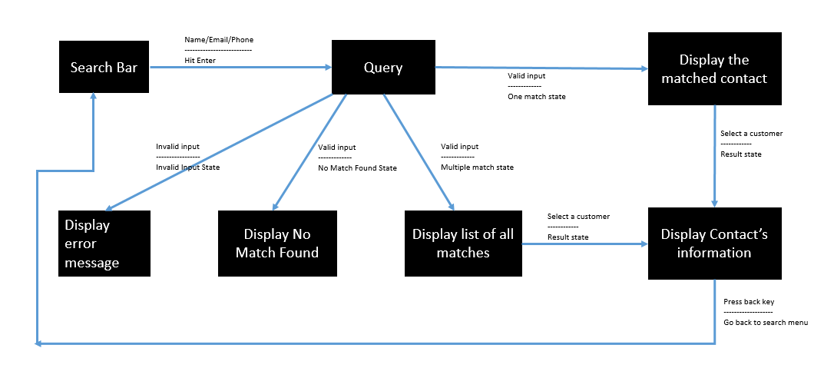

**Gherkin Test Cases**

1. **Scenario:** Search for a contact by their first name

**Given** I am on the contacts page

**When** I enter a valid first name in the search bar

**And** I click the search button

**Then** I should see a list of contacts matching the first name

**And** the list should not contain any contacts with a different first name.

1. **Scenario:** Search for a contact by their last name

**Given** I am on the contacts page

**When** I enter a valid last name in the search bar

**And** I click the search button

**Then** I should see a list of contacts matching the last name

**And** the list should not contain any contacts with a different last name

1. **Scenario:** Search for a contact by their email address

**Given** I am on the contacts page

**When** I enter a valid email address in the search bar

**And** I click the search button

**Then** I should see a list of contacts matching the email address

**And** the list should not contain any contacts with a different email address

1. **Scenario:** Search for a contact by their phone number

**Given** I am on the contacts page

**When** I enter a valid phone number in the search bar

**And** I click the search button

**Then** I should see a list of contacts matching the phone number

**And** the list should not contain any contacts with a different phone number

1. **Scenario**: Search for a contact by their first and last name

**Given** I am on the contacts page

**When** I enter a valid first name and last name in the search bar

**And** I click the search button

**Then** I should see a list of contacts matching the first and last name

**And** the list should not contain any contacts with a different first or last name

1. **Scenario**: Search for a contact by their first name and email address

**Given** I am on the contacts page

**When** I enter a valid first name and email address in the search bar

**And** I click the search button

**Then** I should see a list of contacts matching the first name and email address

**And** the list should not contain any contacts with a different first name or email address

1. **Scenario**: Search for a contact by their last name and email address

**Given** I am on the contacts page

**When** I enter a valid last name and email address in the search bar

**And** I click the search button

**Then** I should see a list of contacts matching the last name and email address

**And** the list should not contain any contacts with a different last name or email address

1. **Scenario**: Search for a contact by their first name, last name and email address

**Given** I am on the contacts page

**When** I enter a valid first name, last name and email address in the search bar

**And** I click the search button

**Then** I should see a list of contacts matching the first name, last name and email address

1. **Scenario**: Search for a contact with invalid email

**Given** the user is on the search page

**When** they enter an email address with invalid characters

**And** click on the search button

**Then** the system should display an error message "Invalid email address entered"

1. **Scenario**: Search for a contact with invalid phone number

**Given** the user is on the search page

**When** they enter a phone number with invalid characters

**And** click on the search button

**Then** the system should display an error message "Invalid phone number entered"

Create New Opportunity CRM Module

**(19L-1229-BCS-8A-2nd User Story and Related Work)**

**User Story:** "As a sales representative in Odoo CRM, I want to be able to create a new opportunity by filling out a small form that asks for the opportunity title, email, phone, expected revenue, and the organization/contact. The opportunity title should be the only required field, and I should have the option to choose an existing contact/organization from the drop-down or create a new one. Once I add the opportunity, it should be added to the first stage of the Kanban view."

**Equivalence Class Partitions:**

I have verified that only required field is Opportunity Title (Cannot be left empty but accepts anything as input, Also no maximum character limit). Rest of fields can be left empty or given a value (all forms of text inputs considered valid). So equivalence class partitions would be:

* Partition 1: Opportunity title is not provided (Invalid)
* Partition 2: Opportunity title is provided (Valid)

**Boundary Value Analysis:**

Boundary Values: 0 Characters, 1 Characters (No max limit)

**State Transition Diagram**

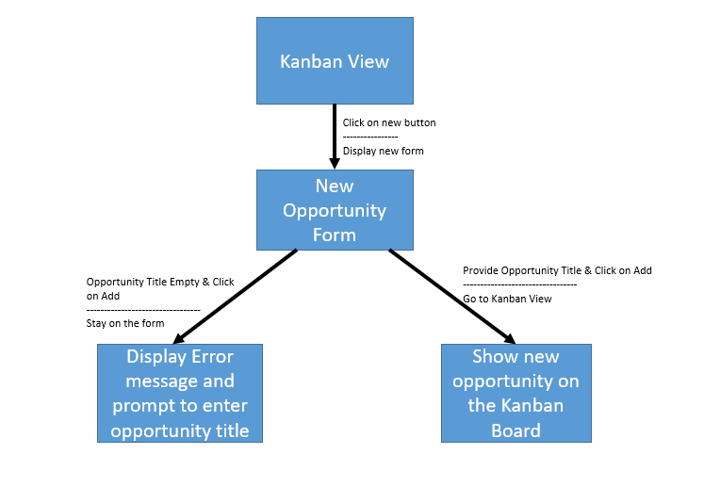

**Gherkin Test Cases**

1. **Scenario**: Create a new opportunity with only required fields

**Given** I am on the Kanban view of the Odoo CRM module

**When** I click on the "New" button and enter "New Bakery Order" in the "Opportunity Title" field

**And** I click the "Add" button

**Then** a new opportunity with the title "New Bakery Order" should be created in the "New" stage of the Kanban view

1. **Scenario**: Create a new opportunity with an existing contact

**Given** I am on the Kanban view of the Odoo CRM module

**And** there is an existing contact called "Azure Interior" in the drop-down list of the "Organization / Contact" field

**When** I click on the "New" button and enter "Wardrobes" in the "Opportunity Title" field

**And** I select “Azure Interior” from the drop-down list

**And** I click the "Add" button

**Then** a new opportunity with the title “Wardrobes” should be created for the contact "Azure Interior" in the "New" stage of the Kanban view

1. **Scenario**: Create a new opportunity with a new contact

**Given** I am on the Kanban view of the Odoo CRM module

**When** I click on the "New" button and enter "Wholesale Bread Order" in the "Opportunity Title" field

**And** I enter "Jane's Bakery" in the "Organization / Contact" field

**And** I enter "jane@janesbakery.com" in the "Email" field

**And** I enter "555-1234" in the "Phone" field

**And** I enter "10000" in the "Expected Revenue" field

**And** I click the "Add" button

**Then** a new opportunity with the title "Wholesale Bread Order" should be created for the new contact "Jane's Bakery" in the "New" stage of the Kanban view

1. **Scenario**: Attempt to create a new opportunity without entering a title

**Given** I am on the Kanban view of the Odoo CRM module

**When** I click on the "New" button

**And** I do not enter anything in the "Opportunity Title" field

**And** I click the "Add" button

**Then** the form should not be submitted

**And** an error message should appear stating that the "Opportunity Title" field is required

1. **Scenario**: Attempt to create a new opportunity with invalid expected revenue

**Given** I am on the Kanban view of the Odoo CRM module

**When** I click on the "New" button and enter "Invalid Revenue" in the "Opportunity Title" field

**And** I enter "-500" in the "Expected Revenue" field

**And** I click the "Add" button

**Then** the form should be submitted

**And** a new opportunity with the title "Invalid Revenue" should be created in the "New" stage of the Kanban view